Ladies & Gentlemen You Are Invited to
A Meal with After-Dinner Speaker
Gary Shapiro (Mount Carmel Messianic Congregation)

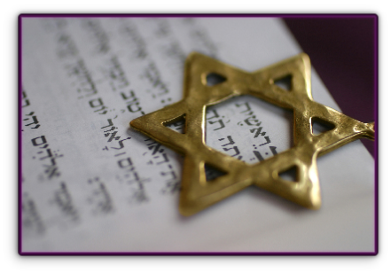

From Fear to Freedom
Gary served in Vietnam with the American Army, 1 year later returned to American as an atheist on drugs. Next he was posted to a town in West Germany bordering Russian occupied East Germany during the Cold War, if that wasn’t bad enough he was also classified as a Jew which frightened him as his grandparents had escaped pogroms of Eastern Europe (before the Nazi’s).
In 1978 Gary moved to Israel, became an Israeli citizen and served in the Israeli Army.
Today, Gary works to combat anti-semitism in the media and in some of our Churches, to encourage harmony between Christians and Jews, teaching the Jewish roots of our faith. At this meal as it is close to Passover, Gary will share some valuable insights that we may have overlooked.
This Story will inspire & encourage.

MONDAY 22nd March 2010 (7-00pm for 7-30pm)

The Arlington Rooms, 905 London Road, Leigh-on-sea, Essex SS9 3LL
(Near Chalkwell Park, almost opposite School)

TWO COURSE MEAL WITH COFFEE/TEA – only £10!
(Steak and Mushroom Pie served with Potatoes & Fresh Vegetables
followed by Bakewell Tart & Custard)
COME AND ENJOY A RELAXED EVENING. BOOK EARLY TO AVOID DISAPPOINTMENT
Please give details of any dietary or vegetarian needs at time of Booking

BOOK ONLINE: www.fgb-southend.org.uk

or PHONE: Cliff on 07980 019217 / 01268 511720 - Reg on 01702 544468
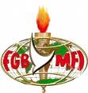
The Dinner is Hosted By:

The Full Gospel Business Men’s Fellowship International

“The Happiest People on Earth”

