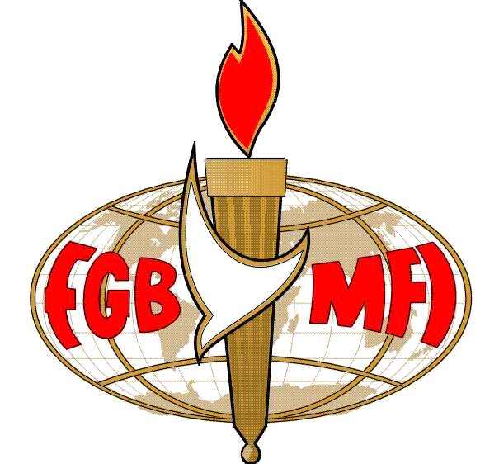
Full Gospel Business Men’s Fellowship International
Southend-on-Sea

Press Release
Date: Tuesday May 6th 2012
Subject: Miracles that Happen Today!
Contact: Cliff Halls, Fellowship President
Tel: 07980 019217 or 01268 511720

Southend’s Full Gospel Business Men’s Fellowship is pleased to announce our next dinner meeting on Monday 2st May 2012 at the Skylark Hotel, Aviation Way, Southend-on-Sea. We have a buffet meal with an exceptional guest speaker in
Colin Springate

Colin was born and bred in Medway, Kent. His start in life was far from promising and, due to a heart defect, he wasn’t expected even to live very long. He astounded the medical profession, however, and providentially survived. Colin is a living miracle and has written a book about the supernatural things he has seen and experienced throughout his life. He retired from his profession as a watch and clock repairer a few years ago and now holds the position of President of the Full Gospel Business Men’s Fellowship International,
Medway Fellowship.
Come and meet Colin as he shares his exciting life story with us of how he became, in the words of our founder, one of the, 'Happiest People on Earth.'

Bookings can be made by phone or on our website. At £12 a head we feel it may be the best investment you’ll ever make! It’s never too late to book.

http://fgb-southend.org.uk

