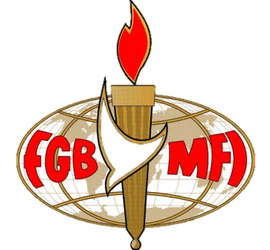

Our Speaker – David Aldous
On God’s Wavelength?
7:30 p.m. Monday 25th February 2013
The Skylark Hotel, Aviation Way, Southend-On-Sea, Essex, SS2 6UN

David was born in Bristol in 1952 and has been a professional actor since 1988 when, after appearing in an amateur film “Self Service” he won the LeHeden Trophy for best acting performance in a competition that was worldwide.

His career has so far has been mostly in television and film although he has made two professional appearances on ‘stage’ in the west-end smash hit “A Slice of Saturday Night”, playing the part of Eric “Rubber Legs” Devine a night club owner, and Eddie, in “Tango”

David’s television credits include ‘Casualty’ for the BBC, ITV’s ‘The Bill’, ‘Peak Practice’, ‘Soldier Soldier’, LWT’s ‘London’s Burning’, Channel 4’s ‘Teenage Health Freak’, ‘Crimewatch’, ‘999’, and ‘The Legacy of Reggie Perrin’.

David presents a radio show called ‘Hope in the Night’, that goes out every night and also a weekly radio programme for ‘Premier Radio’, the Christian radio station for London.

With many fascinating tales to tell this is a dinner not to be missed!

BUFFET MEAL WITH COFFEE/TEA only £12.00
There are a number of meal options. Please let us know if you have any special dietary requirements
To book just go to the website at www.fgb-southend.org.uk
or
Ring Reg Smith on 01702 544468
Michael Liggens on 01268 766553
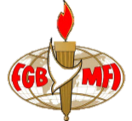
Meetings are open to men and women and you can be assured of a warm welcome.
The dress code is very informal.

