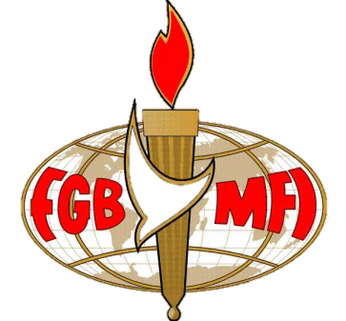
Our Speaker – Jim Wilkinson
Miracle Valley!
7:30 p.m. Monday 22nd April 2013
The Skylark Hotel, Aviation Way, Southend-On-Sea, Essex, SS2 6UN

Our Dinner meeting on Monday 22nd April is going to be another amazing adventure. We are privileged to welcome the author of the Christian classic ‘Miracle Valley,’ Pastor Jim Wilkinson as our guest speaker. Hear the story of how God has over the last 40 years blessed the Hollybush Christian Fellowship. It is truly inspiring - A church on a farm where the miraculous is for today!
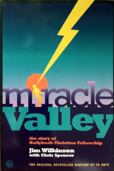

BUFFET MEAL WITH COFFEE/TEA only £12.00
There are a number of meal options. Please let us know if you have any special dietary requirements
To book just go to the website at www.fgb-southend.org.uk
or
Ring Reg Smith on 01702 544468
Colin Bass on 07958 766553
Meetings are open to men and women and you can be assured of a warm welcome.
The dress code is very informal.

