November’s Dinner
Helen Yousaf
The Lady Sings the Gospel Blues

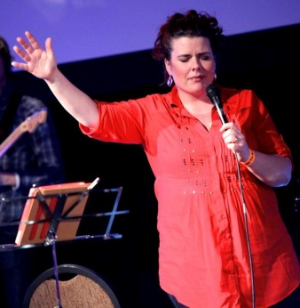

‘Completely and utterly convinced that God is real’

Helen is a singer songwriter who comes from Romford. She became utterly convinced of the reality of God and became a Christian in 1990. But how did this happen and how has her belief changed and inspired her music? Come to our November Dinner and enjoy an evening of musical delight and personal insight.
7:30 p.m. Monday 25th November 2013
The Skylark Hotel, Aviation Way, Southend-On-Sea, Essex, SS2 6UN
BUFFET MEAL WITH COFFEE/TEA only £12.00
There are a number of meal options. Please let us know when booking if you have any special dietary requirements
To book just go to the website
http://fgb-southend.weebly.com/booking.html
or ring
Reg Smith on 01702 544468
Colin Bass on 07958 766553
The dress code is very informal.
All our dinners are open to the general public both men and women and you can be assured of a warm welcome at any of our meals!

*****************************
November’s Dinner
Helen Yousaf
The Lady Sings the Gospel Blues

‘Completely and utterly convinced that God is real’

Helen is a singer songwriter who comes from Romford. She became utterly convinced of the reality of God and became a Christian in 1990. But how did this happen and how has her belief changed and inspired her music? Come to our November Dinner and enjoy an evening of musical delight and personal insight.
7:30 p.m. Monday 25th November 2013
The Skylark Hotel, Aviation Way, Southend-On-Sea, Essex, SS2 6UN
BUFFET MEAL WITH COFFEE/TEA only £12.00
There are a number of meal options. Please let us know when booking if you have any special dietary requirements
To book just go to the website
http://fgb-southend.weebly.com/booking.html
or ring
Reg Smith on 01702 544468
Colin Bass on 07958 766553
The dress code is very informal.
All our dinners are open to the general public both men and women and you can be assured of a warm welcome at any of our meals!

*****************************

