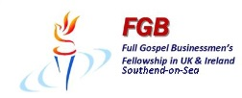

Our Dinner Speaker for February 2014
Philip Edwards
Philip is the pastor of Hope Community Church in West London and is the author of 'Loose Him and Let Him Go', a manual on demonic deliverance, based on 30 years of ministry experience in this area.

Do demons exist or is it all just mumbo-jumbo?
Now is the time to find out at our February Dinner
7:30 p.m. Monday February 24th 2014
The Skylark Hotel, Aviation Way, Southend-On-Sea, Essex, SS2 6UN
BUFFET MEAL WITH COFFEE/TEA only £12.00
There are a number of meal options. Please let us know when booking if you have any special dietary requirements
To book just go to the website
http://fgb-southend.weebly.com/booking.html
or ring
Ring Reg Smith on 01702 544468
Colin Bass on 07958 766553
The dress code is very informal.
All our dinners are open to the general public both men and women
and you can be assured of a warm welcome at any of our meals!

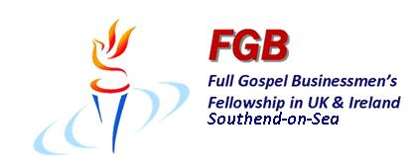

Our Dinner Speaker for February 2014
Philip Edwards
Philip is the pastor of Hope Community Church in West London and is the author of 'Loose Him and Let Him Go', a manual on demonic deliverance, based on 30 years of ministry experience in this area.

Do demons exist or is it all just mumbo-jumbo?
Now is the time to find out at our February Dinner
7:30 p.m. Monday February 24th 2014
The Skylark Hotel, Aviation Way, Southend-On-Sea, Essex, SS2 6UN
BUFFET MEAL WITH COFFEE/TEA only £12.00
There are a number of meal options. Please let us know when booking if you have any special dietary requirements
To book just go to the website
http://fgb-southend.weebly.com/booking.html
or ring
Ring Reg Smith on 01702 544468
Colin Bass on 07958 766553
The dress code is very informal.
All our dinners are open to the general public both men and women
and you can be assured of a warm welcome at any of our meals!

