Our Dinner Speaker for April 2014
John Young
A Life Crafted in Song
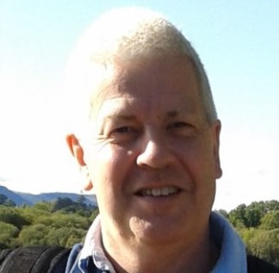

John comes from Hornchurch in Essex and, at the age of 16, he experienced the miraculous when his church prayed for him and he was healed.

He became a successful salesman and worked for a number of major companies including UniChem and Associate Biscuits travelling the country and surviving a number of quite serious car accidents before starting his own successful business in Wickford, Essex with his wife Iréne. Here they own and run ‘In2Crafting’ a shop specialising in a whole array of different crafts.

John is also an excellent musician and plays the drums as part of the worship team at Leigh Elim Church. Perhaps most notable is John’s ministry within the church where he moves in a prophetic ministry speaking to the needs of many.

7:30 p.m. Monday April 28th 2014
The Skylark Hotel, Aviation Way, Southend-On-Sea, Essex, SS2 6UN
BUFFET MEAL WITH COFFEE/TEA only £12.00
There are a number of meal options. Please let us know when booking if you have any special dietary requirements
To book just go to the website
http://fgb-southend.weebly.com/booking.html
or ring
Ring Reg Smith on 01702 544468
Colin Bass on 07958 766553
The dress code is very informal.
All our dinners are open to the general public both men and women and you can be
assured of a warm welcome at any of our meals!

