Our Dinner for June 2014
Steve Goldsbrough
“Shoeshine to Sonshine?”

Steve was brought up in Borstal and of a strongly agnostic persuasion. From this unpromising start, however, he gained success and came to manage a chain of shops selling thousands of pairs of shoes, but shoeshine wasn’t for Steve. Something wonderful happened that changed his life’s focus forever.

Steve will be sharing stories from his own faith journey that brought him in contact with the Muslim world and witnessing the miraculous on the footpaths of Gillingham.

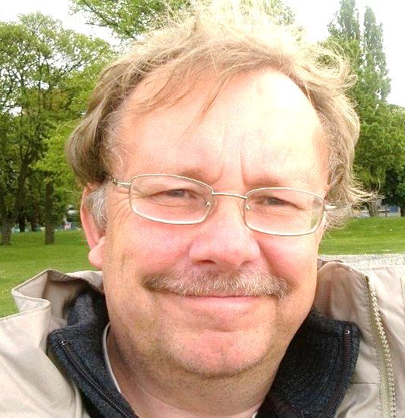

7:30 p.m. Monday June 30th 2014
The Skylark Hotel, Aviation Way, Southend-On-Sea, Essex, SS2 6UN
BUFFET MEAL WITH COFFEE/TEA only £12.00
There are a number of meal options. Please let us know when booking if you have any special dietary requirements
To book just go to the website
http://fgb-southend.weebly.com/booking.html
or ring
Ring Reg Smith on 01702 544468
Colin Bass on 07958 766553
The dress code is very informal.
All our dinners are open to the general public both men and women and you can be
assured of a warm welcome at any of our meals!

