Our Dinner for July 2014
Peter Spreckley – ‘Soliciting for God’
Peter seemed to have life made for him. He had the best education, a lovely wife, three beautiful children, and was part of a very successful solicitors' practice. At the same time, he was a regular church-goer, and even became a church warden.
But alcohol, a fiery temper, and immorality cast their spell and Peter’s marriage and life plunged towards disaster.
Nothing short of a miracle could help. Did Peter find one?
Come and find out at our July dinner meeting!
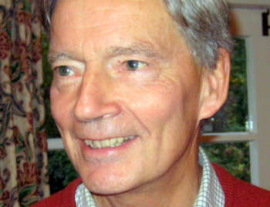

7:30 p.m. Monday 21st July 2014
The Skylark Hotel, Aviation Way, Southend-On-Sea, Essex, SS2 6UN
BUFFET MEAL WITH COFFEE/TEA only £12.00
There are a number of meal options. Please let us know when booking if you have any special dietary requirements
To book just go to the website
http://fgb-southend.weebly.com/booking.html
or ring
Ring Reg Smith on 01702 544468
Colin Bass on 07958 766553
The dress code is very informal.
All our dinners are open to the general public both men and women and you can be
assured of a warm welcome at any of our meals!

