Southend Full Gospel Businessmen
invite you to our October Dinner
Lawrence Kidd
‘The Spiral of Life’

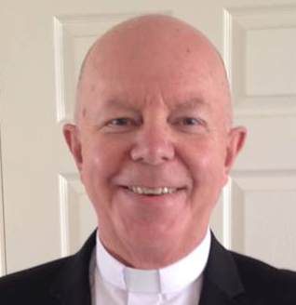

Come along and listen to Lawrence’s amazing story of how he met the living God while driving a truck in the dark in 1985. This encounter was the beginning of an incredible journey that has taken him to many nations across the world:
To see first-hand the power of God with the sick being healed, delivered and people’s lives being set free from darkness.
To experience the moment he faced certain death and how God delivered him from this.
Lawrence is the Author of the book titled “The Spiral of Life”

7:30 p.m. Monday October 27th 2014
The Skylark Hotel, Aviation Way, Southend-On-Sea, Essex, SS2 6UN
BUFFET MEAL WITH COFFEE/TEA only £12.00
There are a number of meal options. Please let us know when booking if you have any special dietary requirements
To book just go to the website
http://fgb-southend.weebly.com/booking.html
or ring
Ring Reg Smith on 01702 544468
Colin Bass on 07958 766553
The dress code is very informal.
All our dinners are open to the general public both men and women and you can be assured of a warm welcome at any of our meals!

Southend Full Gospel Businessmen
invite you to our October Dinner
Lawrence Kidd
‘The Spiral of Life’

Come along and listen to Lawrence’s amazing story of how he met the living God while driving a truck in the dark in 1985. This encounter was the beginning of an incredible journey that has taken him to many nations across the world:
To see first-hand the power of God with the sick being healed, delivered and people’s lives being set free from darkness.
To experience the moment he faced certain death and how God delivered him from this.
Lawrence is the Author of the book titled “The Spiral of Life”

7:30 p.m. Monday October 27th 2014
The Skylark Hotel, Aviation Way, Southend-On-Sea, Essex, SS2 6UN
BUFFET MEAL WITH COFFEE/TEA only £12.00
There are a number of meal options. Please let us know when booking if you have any special dietary requirements
To book just go to the website
http://fgb-southend.weebly.com/booking.html
or ring
Ring Reg Smith on 01702 544468
Colin Bass on 07958 766553
The dress code is very informal.
All our dinners are open to the general public both men and women and you can be assured of a warm welcome at any of our meals!

