Our Dinner Speaker for February 2015
Nigel Langford
Enabling, Equipping and Empowering!
Ever felt in need of a real tonic to get your life back on track? Then Monday 23rd February is for you! Come and hear Nigel Langford’s powerful, engaging and entertaining story. Nigel will be sharing how his life was dynamically changed and how you can find the same focus and satisfaction too.
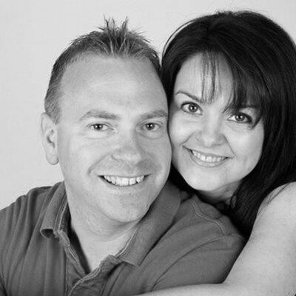

7:30 p.m. Monday February 23rd 2015
The Skylark Hotel, Aviation Way, Southend-On-Sea, Essex, SS2 6UN
BUFFET MEAL WITH COFFEE/TEA only £12.00
There are a number of meal options. Please let us know when booking if you have any special dietary requirements
Please book by Friday 20th February at
http://fgb-southend.weebly.com/booking.html
or ring
Reg Smith on 01702 544468
or
Colin Bass on 07958 766553
The dress code is very informal.
All our dinners are open to the general public both men and women and you can be
assured of a warm welcome at any of our meals!

Our Dinner Speaker for February 2015
Nigel Langford
Enabling, Equipping and Empowering!
Ever felt in need of a real tonic to get your life back on track? Then Monday 23rd February is for you! Come and hear Nigel Langford’s powerful, engaging and entertaining story. Nigel will be sharing how his life was dynamically changed and how you can find the same focus and satisfaction too.

7:30 p.m. Monday February 23rd 2015
The Skylark Hotel, Aviation Way, Southend-On-Sea, Essex, SS2 6UN
BUFFET MEAL WITH COFFEE/TEA only £12.00
There are a number of meal options. Please let us know when booking if you have any special dietary requirements
Please book by Friday 20th February at
http://fgb-southend.weebly.com/booking.html
or ring
Reg Smith on 01702 544468
or
Colin Bass on 07958 766553
The dress code is very informal.
All our dinners are open to the general public both men and women and you can be
assured of a warm welcome at any of our meals!

