Our Dinner Speaker for 30th March 2015
David Measures
‘Freedom from Fear’
It was a film of a hypnotist, in which people would wake from their sleep and do evil things even kill people, that traumatised David. After he had seen the film, he went to the bathroom to wash, when he sensed evil, it came upon his head and went through his body like a snake. David even experienced speaking with a voice that was not his own. He could never seem to get peace in his life; he had a terror of sleeping and became frightened in case he was not in control of his mind.
He was on tablets and had taken tranquilisers from the medical profession, the tragic effects of a film that never left him for 29 years. Until one day freedom!

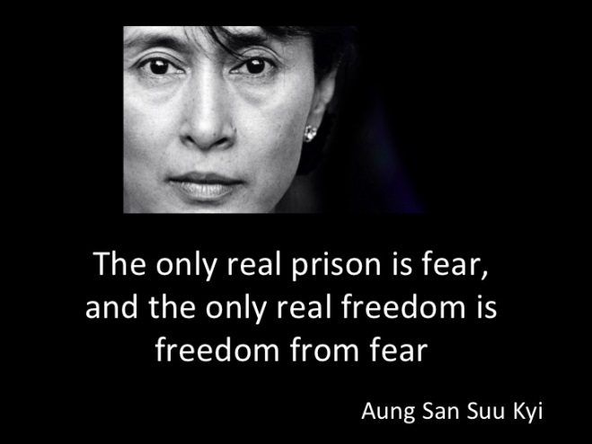

7:30 p.m. Monday March 30th 2015
The Skylark Hotel, Aviation Way, Southend-On-Sea, Essex, SS2 6UN
BUFFET MEAL WITH COFFEE/TEA only £12.00
There are a number of meal options. Please let us know when booking if you have any special dietary requirements
Please book by Friday 27th March at
http://fgb-southend.weebly.com/booking.html
or ring
Andy Parker on 01245 346906 Mobile 07817 873562 - Colin Bass on 07958 766553

The dress code is very informal.
All our dinners are open to the general public both men and women and you can be
assured of a warm welcome at any of our meals!

Our Dinner Speaker for 30th March 2015
David Measures
‘Freedom from Fear’
It was a film of a hypnotist, in which people would wake from their sleep and do evil things even kill people, that traumatised David. After he had seen the film, he went to the bathroom to wash, when he sensed evil, it came upon his head and went through his body like a snake. David even experienced speaking with a voice that was not his own. He could never seem to get peace in his life; he had a terror of sleeping and became frightened in case he was not in control of his mind.
He was on tablets and had taken tranquilisers from the medical profession, the tragic effects of a film that never left him for 29 years. Until one day freedom!

7:30 p.m. Monday March 30th 2015
The Skylark Hotel, Aviation Way, Southend-On-Sea, Essex, SS2 6UN
BUFFET MEAL WITH COFFEE/TEA only £12.00
There are a number of meal options. Please let us know when booking if you have any special dietary requirements
Please book by Friday 27th March at
http://fgb-southend.weebly.com/booking.html
or ring
Andy Parker on 01245 346906 Mobile 07817 873562 - Colin Bass on 07958 766553

The dress code is very informal.
All our dinners are open to the general public both men and women and you can be
assured of a warm welcome at any of our meals!

