Southend-on-Sea

Full Gospel Businessmen

Invite you to our December Dinner Meeting to hear our guest speaker
David Hathaway

Southend FGB welcome internationally renowned Christian evangelist David Hathaway to our December meal. David is used to speaking to crowds of up to 70,000 at a time, yes 70,000! He has, however, found time in his busy schedule to come and share with us. We only have very limited places for what is going to be a tremendous evening. Please book very early to avoid disappointment.

To any who haven’t been to one of our dinners before we offer a free meal. All you need to do is book and let Andy Parker or Colin Bass know you’ve not attended before and would like to come as a Fellowship guest.
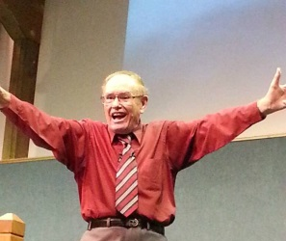
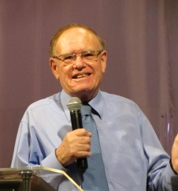
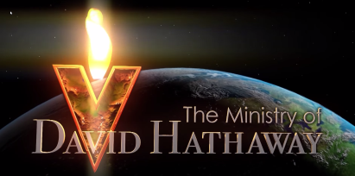

Monday 7th December 2015 at 7:30 p.m.
The Skylark Hotel, Aviation Way, Southend-On-Sea, Essex, SS2 6UN
BUFFET MEAL WITH COFFEE/TEA only £12.00
There are a number of meal options. Please let us know when booking if you have any special dietary requirements
Please book by Friday 27th November at fgb-southend.weebly.com
or ring
Andy Parker 07817 873562 - Colin Bass 07958 766553

It’s not a formal dinner and the dress code is casual.
All our dinners are open to the general public both men and women and you can be assured of a warm welcome at any of our meals!

