Southend-on-Sea

Full Gospel Businessmen

Invite you to our February Dinner Meeting to hear our guest speaker
Maldwyn Holland
‘The Runaway’

Brought up in an unhappy family with an angry and unkind father Maldywn ran away at a young age and lived in a horsebox on a hill. Not the most promising of starts in life but Maldwyn was to experience something so profound it turned his life around. Where could a runaway run with nowhere else to go? Come and find out at our exciting dinner on Monday 29th February.

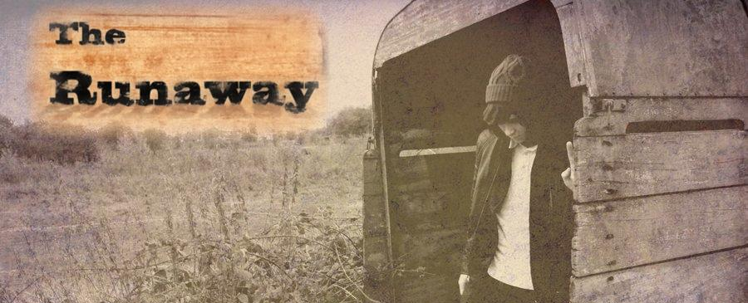

Monday 29th February 2016 at 7:30 p.m.
The Skylark Hotel, Aviation Way, Southend-On-Sea, Essex, SS2 6UN
BUFFET MEAL WITH COFFEE/TEA only £12.00
There are a number of meal options. Please let us know when booking if you have any special dietary requirements
Please book by Friday 26th February at fgbuk-southend.weebly.com
or ring
Andy Parker 07817 873562 - Colin Bass 07958 766553
All our dinners are open to the general public both men and women and you can be assured of a warm welcome at any of our meals!

Southend-on-Sea

Full Gospel Businessmen

Invite you to our February Dinner Meeting to hear our guest speaker
Maldwyn Holland
‘The Runaway’

Brought up in an unhappy family with an angry and unkind father Maldywn ran away at a young age and lived in a horsebox on a hill. Not the most promising of starts in life but Maldwyn was to experience something so profound it turned his life around. Where could a runaway run with nowhere else to go? Come and find out at our exciting dinner on Monday 29th February.

Monday 29th February 2016 at 7:30 p.m.
The Skylark Hotel, Aviation Way, Southend-On-Sea, Essex, SS2 6UN
BUFFET MEAL WITH COFFEE/TEA only £12.00
There are a number of meal options. Please let us know when booking if you have any special dietary requirements
Please book by Friday 26th February at fgbuk-southend.weebly.com
or ring
Andy Parker 07817 873562 - Colin Bass 07958 766553
All our dinners are open to the general public both men and women and you can be assured of a warm welcome at any of our meals!

