An Excellent Buffet Meal
An Inspirational After-dinner Speaker
An Informal Evening for All

We invite you to our September 2016 Dinner to be inspired by

Steve Murray
Mime and Human Theatre performer extraordinaire
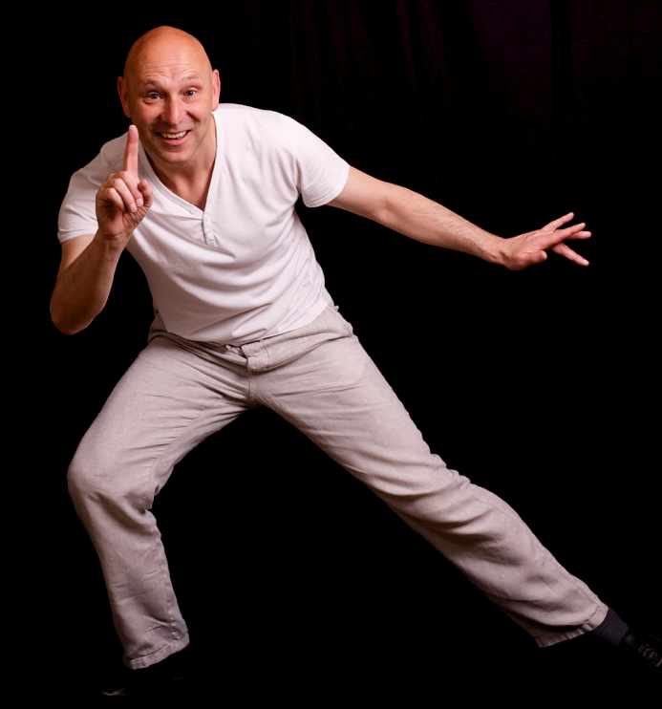

Monday 26th September 2016 at 7:30 p.m.

The Skylark Hotel, Aviation Way, Southend-On-Sea, Essex, SS2 6UN
BUFFET MEAL WITH COFFEE/TEA only £12.00
Please let us know when booking if you have any special dietary requirements
A free meal to all coming for the first time
For more information or to book your dinners please ring
Andy Parker 07817 873562 - Colin Bass 07958 766553
Or go to our website at fgbuk-southend.weebly.com

All our meetings are open to the general public both men and women and you can be assured of a warm welcome at any of our dinners. Newcomers especially welcome.
Can’t make it this month? Come to our dinner on 7th November!
An Excellent Buffet Meal
An Inspirational After-dinner Speaker
An Informal Evening for All

We invite you to our September 2016 Dinner to be inspired by

Steve Murray
Mime and Human Theatre performer extraordinaire

Monday 26th September 2016 at 7:30 p.m.

The Skylark Hotel, Aviation Way, Southend-On-Sea, Essex, SS2 6UN
BUFFET MEAL WITH COFFEE/TEA only £12.00
Please let us know when booking if you have any special dietary requirements
A free meal to all coming for the first time
For more information or to book your dinners please ring
Andy Parker 07817 873562 - Colin Bass 07958 766553
Or go to our website at fgbuk-southend.weebly.com

All our meetings are open to the general public both men and women and you can be assured of a warm welcome at any of our dinners. Newcomers especially welcome.
Can’t make it this month? Come to our dinner on 7th November!

