'FGB'
Sharing remarkable NEW LIFE stories

A warm welcome to our November Dinner to hear our guest speaker

Ken Stallard

What do the Duke and Duchess of Windsor and the Kray Twins have in Common?
Don't know?
​Come and find out!
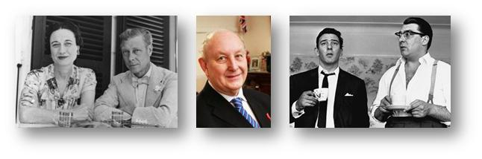

Monday 7th November 2016 at 7:30 p.m.

The Skylark Hotel, Aviation Way, Southend-On-Sea, Essex, SS2 6UN
BUFFET MEAL WITH COFFEE/TEA only £12.00
Please let us know when booking if you have any special dietary requirements
A free meal to all coming for the first time
For more information or to book your dinners please ring
Reg Smith on 01702 544468 or 0780 6506460
Or go to our website at fgbuk-southend.weebly.com

All our meetings are open to the general public both men and women and you can be assured of a warm welcome at any of our dinners. Newcomers especially welcome.

'FGB'
Sharing remarkable NEW LIFE stories

A warm welcome to our November Dinner to hear our guest speaker

Ken Stallard

What do the Duke and Duchess of Windsor and the Kray Twins have in Common?
Don't know?
​Come and find out!

Monday 7th November 2016 at 7:30 p.m.

The Skylark Hotel, Aviation Way, Southend-On-Sea, Essex, SS2 6UN
BUFFET MEAL WITH COFFEE/TEA only £12.00
Please let us know when booking if you have any special dietary requirements
A free meal to all coming for the first time
For more information or to book your dinners please ring
Reg Smith on 01702 544468 or 0780 6506460
Or go to our website at fgbuk-southend.weebly.com

All our meetings are open to the general public both men and women and you can be assured of a warm welcome at any of our dinners. Newcomers especially welcome.

