Coming to Canvey for one night only

David Hathaway

International Speaker on current and future events David
speaks in Europe to crowds in their thousands. We are privileged that he has taken time out of his busy schedule to be with us on
Saturday 3rd December

Imprisoned for smuggling Bibles into what was Czechoslovakia, the Prime Minister Harold Wilson personally flew out to negotiate his release. This was an answer to prayer and his story of the miraculous working of God over the past 60 years is an inspiration to all. On Saturday his theme will be:

“What Does the Future Hold? – What the Bible says ..”

Saturday 3rd December 2016 at 7:30 p.m.- 9:30 p.m.
The Paddocks Community Centre,
Long Road, Canvey Island, SS8 0JA

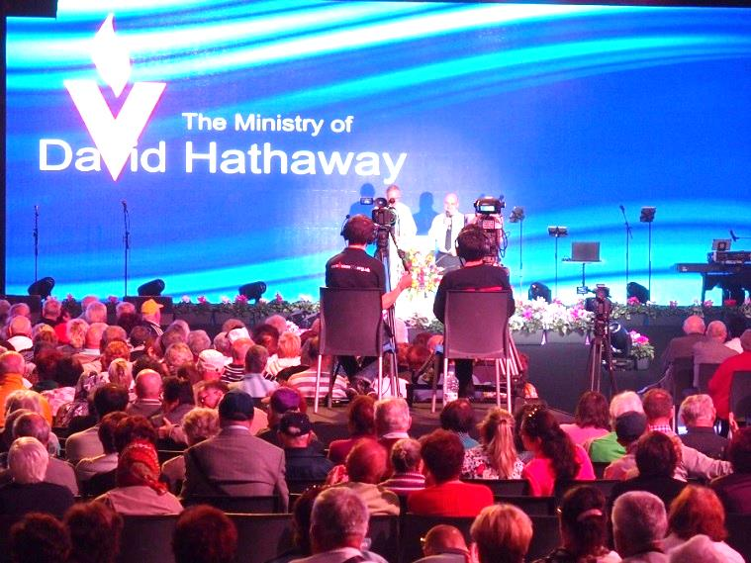

Entrance is free and there is no need to book
For more information please ring Andy Parker 07817 873562
fgbuk-southend.weebly.com

More about David’s Ministry may also be found on his website at propheticvision.org.uk

Coming to Canvey for one night only

David Hathaway

International Speaker on current and future events David
speaks in Europe to crowds in their thousands. We are privileged that he has taken time out of his busy schedule to be with us on
Saturday 3rd December

Imprisoned for smuggling Bibles into what was Czechoslovakia, the Prime Minister Harold Wilson personally flew out to negotiate his release. This was an answer to prayer and his story of the miraculous working of God over the past 60 years is an inspiration to all. On Saturday his theme will be:

“What Does the Future Hold? – What the Bible says ..”

Saturday 3rd December 2016 at 7:30 p.m.- 9:30 p.m.
The Paddocks Community Centre,
Long Road, Canvey Island, SS8 0JA

Entrance is free and there is no need to book
For more information please ring Andy Parker 07817 873562
fgbuk-southend.weebly.com

More about David’s Ministry may also be found on his website at propheticvision.org.uk
